**Aim – Introduction to grouping clauses GROUP BY ORDER BY ,HAVING and views**

Create table customers with attributes custid , name, and country.

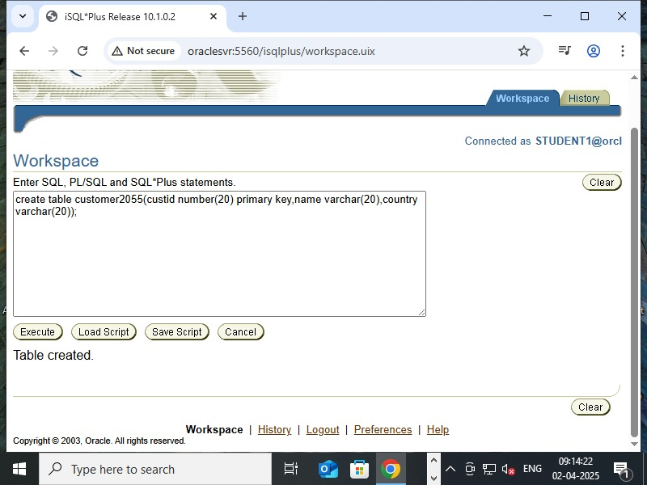

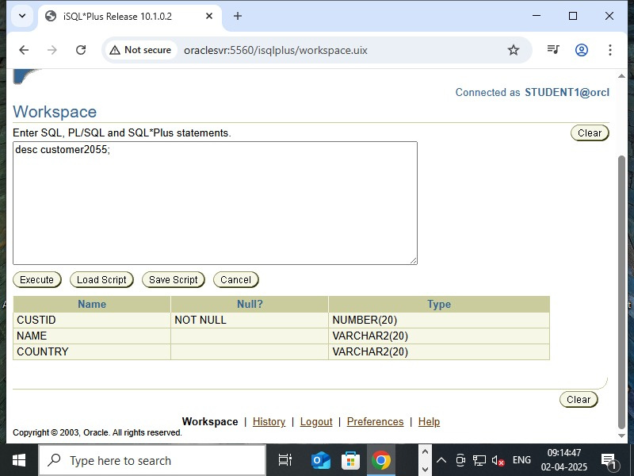

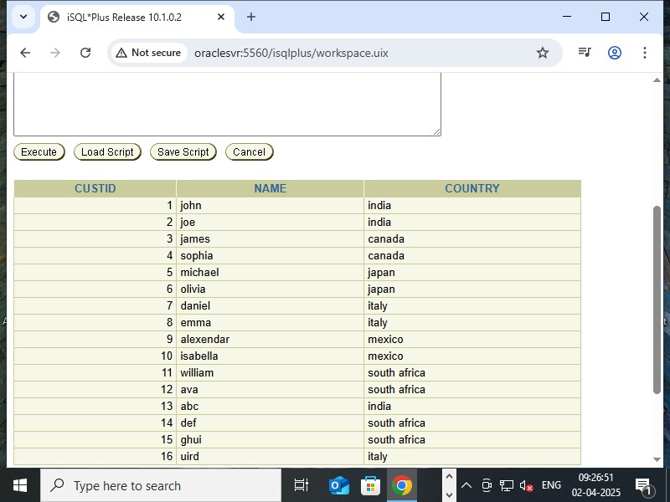

* Select COUNT(custid),country from customer2055 GROUP BY country;

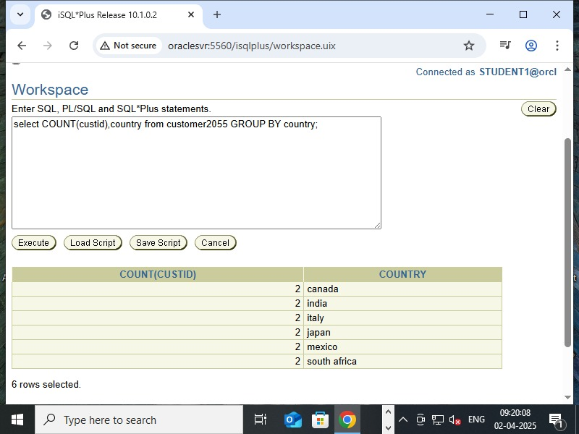

* Select count(custid),country from customer2055 GROUP BY country having count (custid)>2;

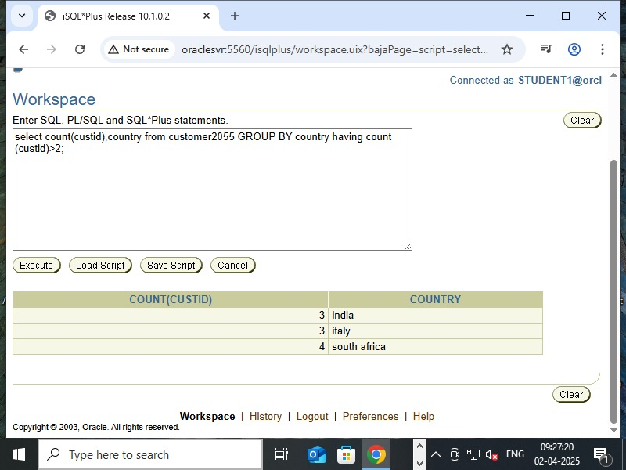

* Select count(custid),country from customer2055 GROUP BY country having count (custid)>2 order by count(custid) asc,country desc;

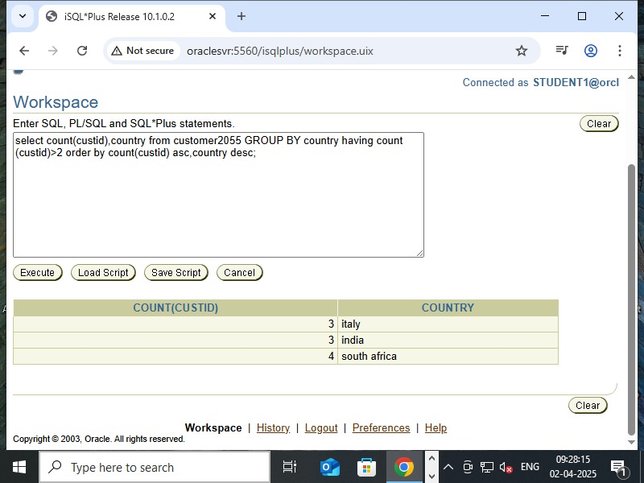

* Create view custview as select* from customers;

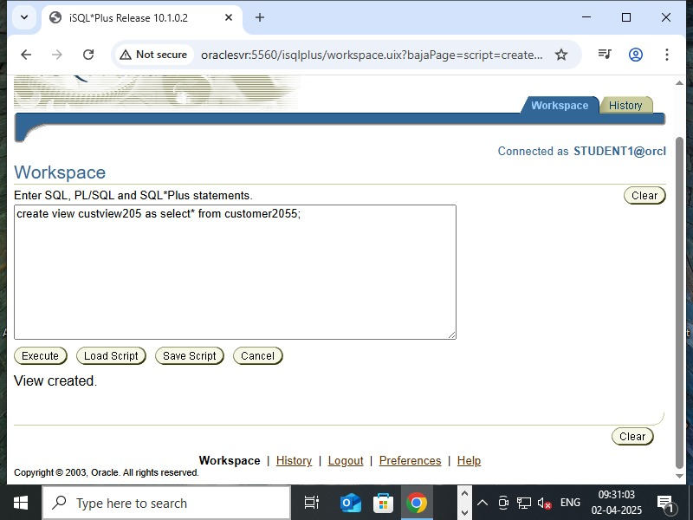

* Drop view custview205;

